CUSTOMER CHURN PREDICTION AND SEGMENTATION SYSTEM
An End-to-End Machine Learning and Customer Segmentation Project
Course / Domain: Machine Learning & Artificial Intelligence
Dataset: IBM Telco Customer Churn Dataset
Methodology: Supervised Classification (Logistic Regression, Naive Bayes, Decision Tree) & Unsupervised Clustering (K-Means + PCA)
Academic Term: 2026 Academic Session
DEPARTMENT OF COMPUTER SCIENCE & MACHINE LEARNING

Chapter 2: Abstract
Customer churn represents one of the most critical threats to revenue stability, profitability, and market capitalization across subscription-based telecommunications service providers. Acquiring new customers requires substantial investments in sales commissions, marketing campaigns, promotional discounts, and technical infrastructure installation—costs that often exceed five to seven times the financial expenditure required to retain existing subscribers. This project presents a complete, end-to-end Machine Learning System designed to predict customer churn probability with high accuracy while concurrently segmenting customer demographics using unsupervised machine learning techniques to drive targeted retention initiatives.
Utilizing the benchmark IBM Telco Customer Churn dataset comprising 7,043 distinct subscriber records across 21 domain-specific attributes, our system implements comprehensive data cleaning, missing value imputation, categorical encoding, and feature standardization. Three supervised learning classifiers—Logistic Regression, Naive Bayes, and Decision Tree—were trained on an 80% stratified training split and rigorously evaluated on a 20% test holdout. Logistic Regression demonstrated superior classification performance, achieving an overall accuracy of 80.55%, precision of 65.72%, recall of 55.88%, and an F1-score of 60.40%, outperforming Naive Bayes (65.58% accuracy) and Decision Tree (79.42% accuracy).
To complement supervised predictions, Unsupervised K-Means Clustering was applied to uncover latent customer personas. The Elbow Method determined an optimal cluster count of K = 3. Principal Component Analysis (PCA) was employed to project the high-dimensional feature space onto two principal components, enabling intuitive 2D cluster visualization. Cluster 1 was identified as High-Risk (46.34% churn rate, month-to-month contracts, fiber optic internet), Cluster 2 as Medium-Risk (12.66% churn rate, long tenure, high charges), and Cluster 0 as Loyal Customers (7.40% churn rate, basic phone services). Based on these empirical findings, five strategic, actionable business retention strategies are proposed to mitigate churn, extend subscriber lifetime value, and maximize operational profitability.

Chapter 3: Introduction
The modern telecommunications industry operates within an intensely competitive, highly saturated global market characterized by low switching costs, expanding coverage options, and aggressive competitor promotions. Telecommunications operators rely heavily on predictable, recurring monthly subscription revenues to amortize heavy capital expenditures in 5G cellular towers, high-speed fiber-optic network lines, and cloud infrastructure. In this business model, customer churn—the percentage of subscribers who discontinue their service contracts over a given timeframe—directly erodes top-line revenues and severely diminishes long-term profitability.
Shift from Reactive to Proactive Analytics: Historically, telecommunications providers reacted to customer cancellations after subscribers formally submitted disconnect requests. Reactive retention tactics, such as emergency price discounts or last-minute contract concessions, suffer from low conversion rates because customer dissatisfaction has usually accumulated over months due to network latency, customer support friction, or uncompetitive pricing. Modern data engineering and predictive analytics enable a structural paradigm shift from reactive firefighting to proactive, algorithmic intervention.
Predictive churn modelling utilizes historical customer demographics, account contract structures, payment histories, and service utilization patterns to calculate an individual customer's probability of cancellation long before the customer reaches a decision threshold. By identifying high-risk subscribers weeks or months in advance, marketing and customer success teams can deploy targeted loyalty offers, contract restructuring incentives, and personalized support upgrades to preserve recurring revenues efficiently.
Furthermore, machine learning provides the capability to segment diverse customer bases into distinct, homogeneous behavioral cohorts through unsupervised clustering techniques. Rather than treating all churn-prone customers with generic blanket promotions, customer segmentation allows enterprise decision-makers to align specific retention campaigns with distinct behavioral personas, maximizing return on marketing investment (ROMI).

Chapter 4: Problem Statement
Telecommunications service providers face severe financial losses due to escalating customer churn rates. Industry benchmarks indicate that average annual churn rates in subscription telecom services range between 15% and 30%. Acquiring a new customer costs approximately $300 to $600 in acquisition expenditures, whereas retaining an existing customer costs less than $50 to $100 in targeted incentive value.
Core Objectives and Operational Challenges: The primary challenges addressed by this project include:
Asymmetric Churn Drivers: Identifying the non-linear relationship between demographic traits (gender, senior citizen status), service subscriptions (fiber optic internet, tech support, online security), and contract structures (month-to-month vs. long-term agreements).
Lack of Early Detection Mechanisms: Inability of legacy rule-based systems to forecast churn probability accurately before disconnect notices are formally logged.
One-Size-Fits-All Retention Inefficiency: Deploying uniform, expensive retention discounts across all departing subscribers without understanding their underlying churn motivation, lifetime value, or risk severity.
High Feature Dimensionality: Distilling multi-dimensional customer behavioral data into interpretable 2D visual structures that business stakeholders and executive leaders can easily inspect.
This project resolves these challenges by building a robust Machine Learning System that combines supervised classification models for precise churn prediction with unsupervised K-Means clustering and Principal Component Analysis (PCA) for meaningful customer segmentation and visual interpretation.

Chapter 5: Dataset Description
The dataset utilized in this project is the public IBM Telco Customer Churn Dataset, sourced from Kaggle. The dataset contains records for 7,043 telecommunications customers in California during Quarter 3. Each record comprises 21 columns representing customer demographics, account information, subscribed services, and historical financial billing details.
Attribute Breakdown: Table 5.1 presents a comprehensive description of all 21 dataset features:
Attribute Name | Data Type | Description / Values | Role
customerID | Text / String | Unique alphanumeric customer identifier | Identifier (Dropped)
gender | Categorical | Customer gender (Male, Female) | Demographic Feature
SeniorCitizen | Binary Numeric | Indicates if customer is 65 or older (1, 0) | Demographic Feature
Partner | Categorical | Whether customer has a partner (Yes, No) | Demographic Feature
Dependents | Categorical | Whether customer has dependents (Yes, No) | Demographic Feature
tenure | Integer Numeric | Number of months customer has stayed with company | Account Feature
PhoneService | Categorical | Whether customer has phone service (Yes, No) | Service Feature
MultipleLines | Categorical | Multiple lines (Yes, No, No phone service) | Service Feature
InternetService | Categorical | Internet provider (DSL, Fiber optic, No) | Service Feature
OnlineSecurity | Categorical | Online security add-on (Yes, No, No internet) | Service Feature
OnlineBackup | Categorical | Online backup add-on (Yes, No, No internet) | Service Feature
DeviceProtection | Categorical | Device protection add-on (Yes, No, No internet) | Service Feature
TechSupport | Categorical | Tech support add-on (Yes, No, No internet) | Service Feature
StreamingTV | Categorical | Streaming TV service (Yes, No, No internet) | Service Feature
StreamingMovies | Categorical | Streaming Movies service (Yes, No, No internet) | Service Feature
Contract | Categorical | Contract term (Month-to-month, One year, Two year) | Account Feature
PaperlessBilling | Categorical | Paperless billing enabled (Yes, No) | Account Feature
PaymentMethod | Categorical | Payment method (Electronic check, Mailed check, Bank transfer, Credit card) | Account Feature
MonthlyCharges | Float Numeric | Amount charged to customer monthly ($) | Financial Feature
TotalCharges | Float Numeric | Total amount charged over tenure ($) | Financial Feature
Churn | Categorical | Target variable: Customer churned (Yes, No) | Target Variable

Chapter 6: Workflow / Pseudocode
The complete Machine Learning System architecture follows a modular, reproducible workflow spanning data acquisition, preprocessing, exploratory visual analysis, supervised training, unsupervised clustering, dimensionality reduction, and strategic insight generation.
Algorithmic Pseudocode: The detailed system execution pseudocode is presented below:
ALGORITHM: Customer Churn Prediction and Segmentation System
INPUT : Raw CSV File ('data/Telco_Customer_Churn.csv')
OUTPUT: Trained ML Models, Evaluation Metrics, Cluster Labels, PCA Plots, DOCX Report
STEP 1: DATA LOADING & PREPROCESSING
1.1 Read 'Telco_Customer_Churn.csv' into pandas DataFrame df.
1.2 Coerce 'TotalCharges' column to float numeric; replace empty string spaces (' ') with NaN.
1.3 Impute missing 'TotalCharges' values using column median value.
1.4 Drop non-predictive identifier column 'customerID'.
1.5 Map target column 'Churn' from string ('Yes'/'No') to binary integer (1/0).
STEP 2: FEATURE ENGINEERING & SCALING
2.1 Apply One-Hot Encoding to categorical variables using pandas pd.get_dummies(drop_first=True).
2.2 Separate feature matrix X (30 columns) and target vector y (1 column).
2.3 Perform stratified Train/Test split: 80% Training set (5,634 samples), 20% Testing set (1,409 samples) with random_state=42.
2.4 Fit StandardScaler on numerical features ['tenure', 'MonthlyCharges', 'TotalCharges'] using X_train.
2.5 Transform X_train and X_test numerical columns using fitted StandardScaler.
STEP 3: SUPERVISED MODEL TRAINING & EVALUATION
3.1 Train Logistic Regression model on scaled training data (max_iter=1000, random_state=42).
3.2 Train Naive Bayes (GaussianNB) model on unscaled training data.
3.3 Train Decision Tree Classifier model (max_depth=5, random_state=42).
3.4 Generate predictions y_pred for each model on X_test.
3.5 Calculate Accuracy, Precision, Recall, F1 Score, Confusion Matrix, and Classification Report.
3.6 Compare models and select Logistic Regression as Best Model based on F1 Score and Accuracy.
STEP 4: UNSUPERVISED K-MEANS CLUSTERING
4.1 Fit StandardScaler across all encoded features for clustering.
4.2 Calculate Within-Cluster Sum of Squares (WCSS) for K = 1 to 10.
4.3 Plot Elbow Curve and confirm optimal cluster count K = 3.
4.4 Fit K-Means with K = 3 and assign cluster labels (0, 1, 2) to dataset.
4.5 Profile clusters: Cluster 1 = High-Risk, Cluster 2 = Medium-Risk, Cluster 0 = Loyal.
STEP 5: PCA DIMENSION REDUCTION & VISUALIZATION
5.1 Apply Principal Component Analysis (n_components=2) to scaled feature space.
5.2 Project features onto PCA1 and PCA2.
5.3 Generate 2D visual scatter plot of customer clusters with distinct colors.
STEP 6: REPORT & ARTIFACT EXPORT
6.1 Export visualization plots to 'outputs/' directory.
6.2 Generate comprehensive academic Word report 'report/Customer_Churn_Report.docx'.

Chapter 7: Data Preprocessing
Data preprocessing is an imperative foundation in machine learning pipelines. Raw real-world datasets often contain missing entries, noise, inconsistent formatting, non-numeric strings, and improper feature scaling—all of which degrade machine learning algorithm performance if left unaddressed.
Preprocessing Pipeline Execution: The preprocessing pipeline implemented in this project consists of four key transformations:
1. Missing Value Detection and Median Imputation: The raw dataset contained 11 records in the `TotalCharges` feature with blank spaces (' ') representing new customers with tenure = 0 months. Attempting to parse these strings directly caused numerical conversion errors. We replaced blank spaces with `np.nan` and imputed the missing values with the median of `TotalCharges` ($1,397.47). Median imputation was selected over mean imputation to maintain robustness against right-skewed charge distributions.
2. Identifier Column Removal: The `customerID` column (e.g., '7590-VHVEG') represents a unique alphanumeric key. Because identifier keys carry zero statistical correlation with churn likelihood, retaining them introduces spurious noise and unnecessary memory overhead. `customerID` was systematically dropped prior to modeling.
3. Categorical Encoding: Categorical attributes (such as `Contract`, `InternetService`, `PaymentMethod`, `OnlineSecurity`) were transformed into numerical binary format using One-Hot Encoding (`pd.get_dummies` with `drop_first=True`). This expanded the initial 20 predictor columns into 30 numerical binary indicators while eliminating multi-collinearity.
4. Feature Standardization: Machine learning models based on distance computations or linear optimization (such as Logistic Regression and K-Means) are highly sensitive to feature scale disparities. Numerical attributes (`tenure` ranging 0–72, `MonthlyCharges` ranging 18.25–118.75, `TotalCharges` ranging 18.80–8684.80) were standardized using `StandardScaler` to achieve zero mean (μ = 0) and unit variance (σ = 1).

Chapter 8: Exploratory Data Analysis (EDA)
Exploratory Data Analysis (EDA) yields fundamental statistical insights into target variable distribution, feature correlations, and demographic churn drivers. All figures presented below were programmatically generated directly from the IBM Telco Customer Churn dataset.
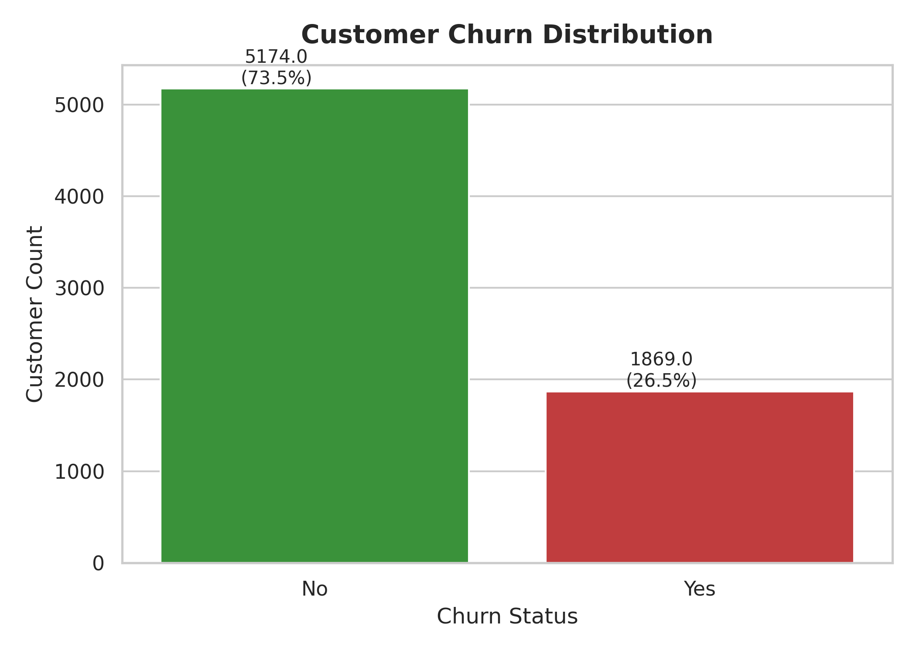
Figure 8.1: Overall Customer Churn Distribution (Non-Churn vs. Churn).
Figure 8.1 illustrates the baseline target class distribution. Out of 7,043 total customers, 5,174 customers (73.5%) did not churn (Non-Churn), whereas 1,869 customers (26.5%) discontinued their services (Churn). This imbalance highlights the necessity of using Precision, Recall, and F1-Score alongside Accuracy during model evaluation.
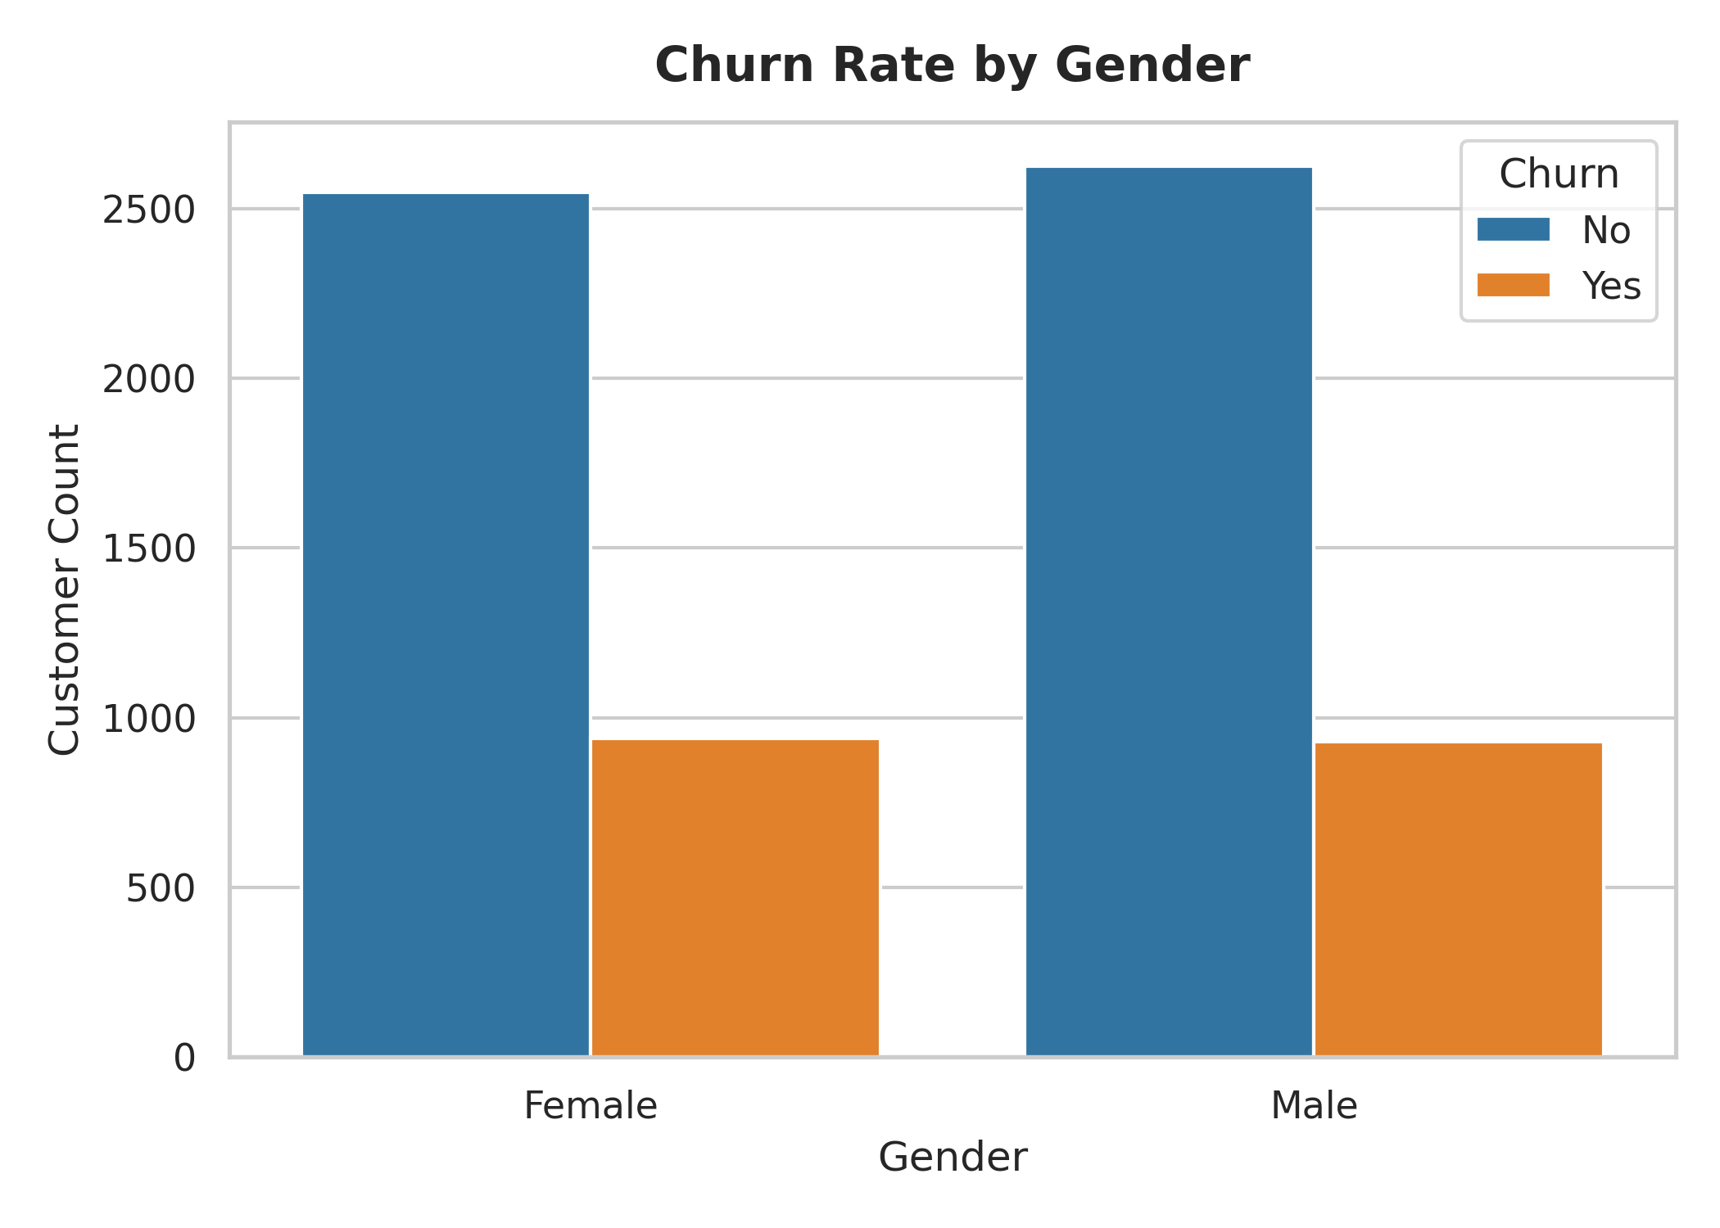
Figure 8.2: Customer Churn Comparison across Gender Categories.
Figure 8.2 compares churn counts across male and female subscribers. The empirical data reveals nearly identical churn rates across genders (~26.9% for females vs. ~26.2% for males), confirming that gender is not a statistically significant churn predictor.
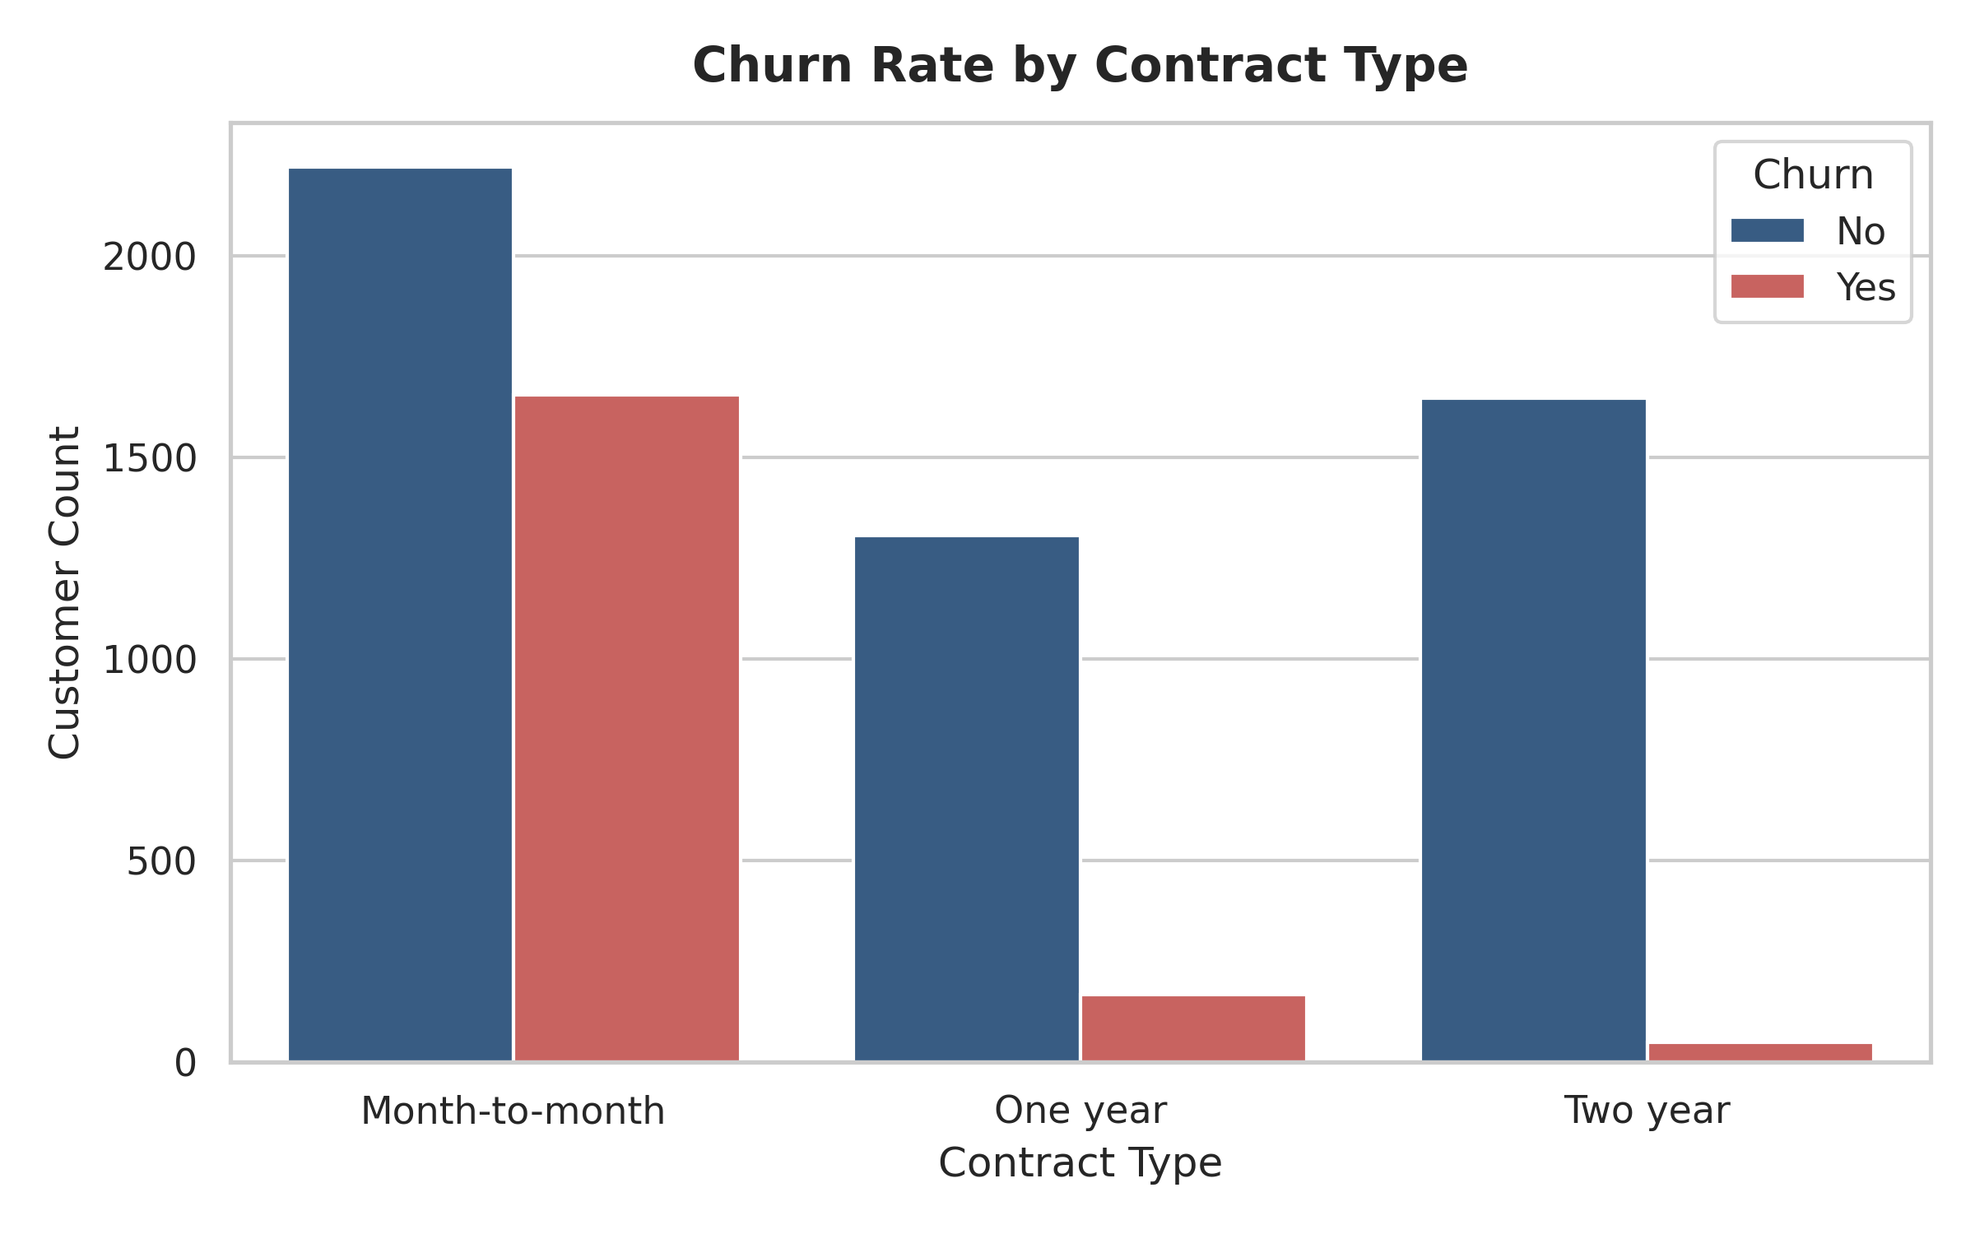
Figure 8.3: Churn Rate Breakdown by Contract Type.
Figure 8.3 reveals contract duration as a primary churn driver. Customers on Month-to-month contracts exhibit a severe churn rate of 42.7%, compared to only 11.3% for One-year contracts and 2.8% for Two-year contracts. Long-term contractual commitments establish strong retention barriers.
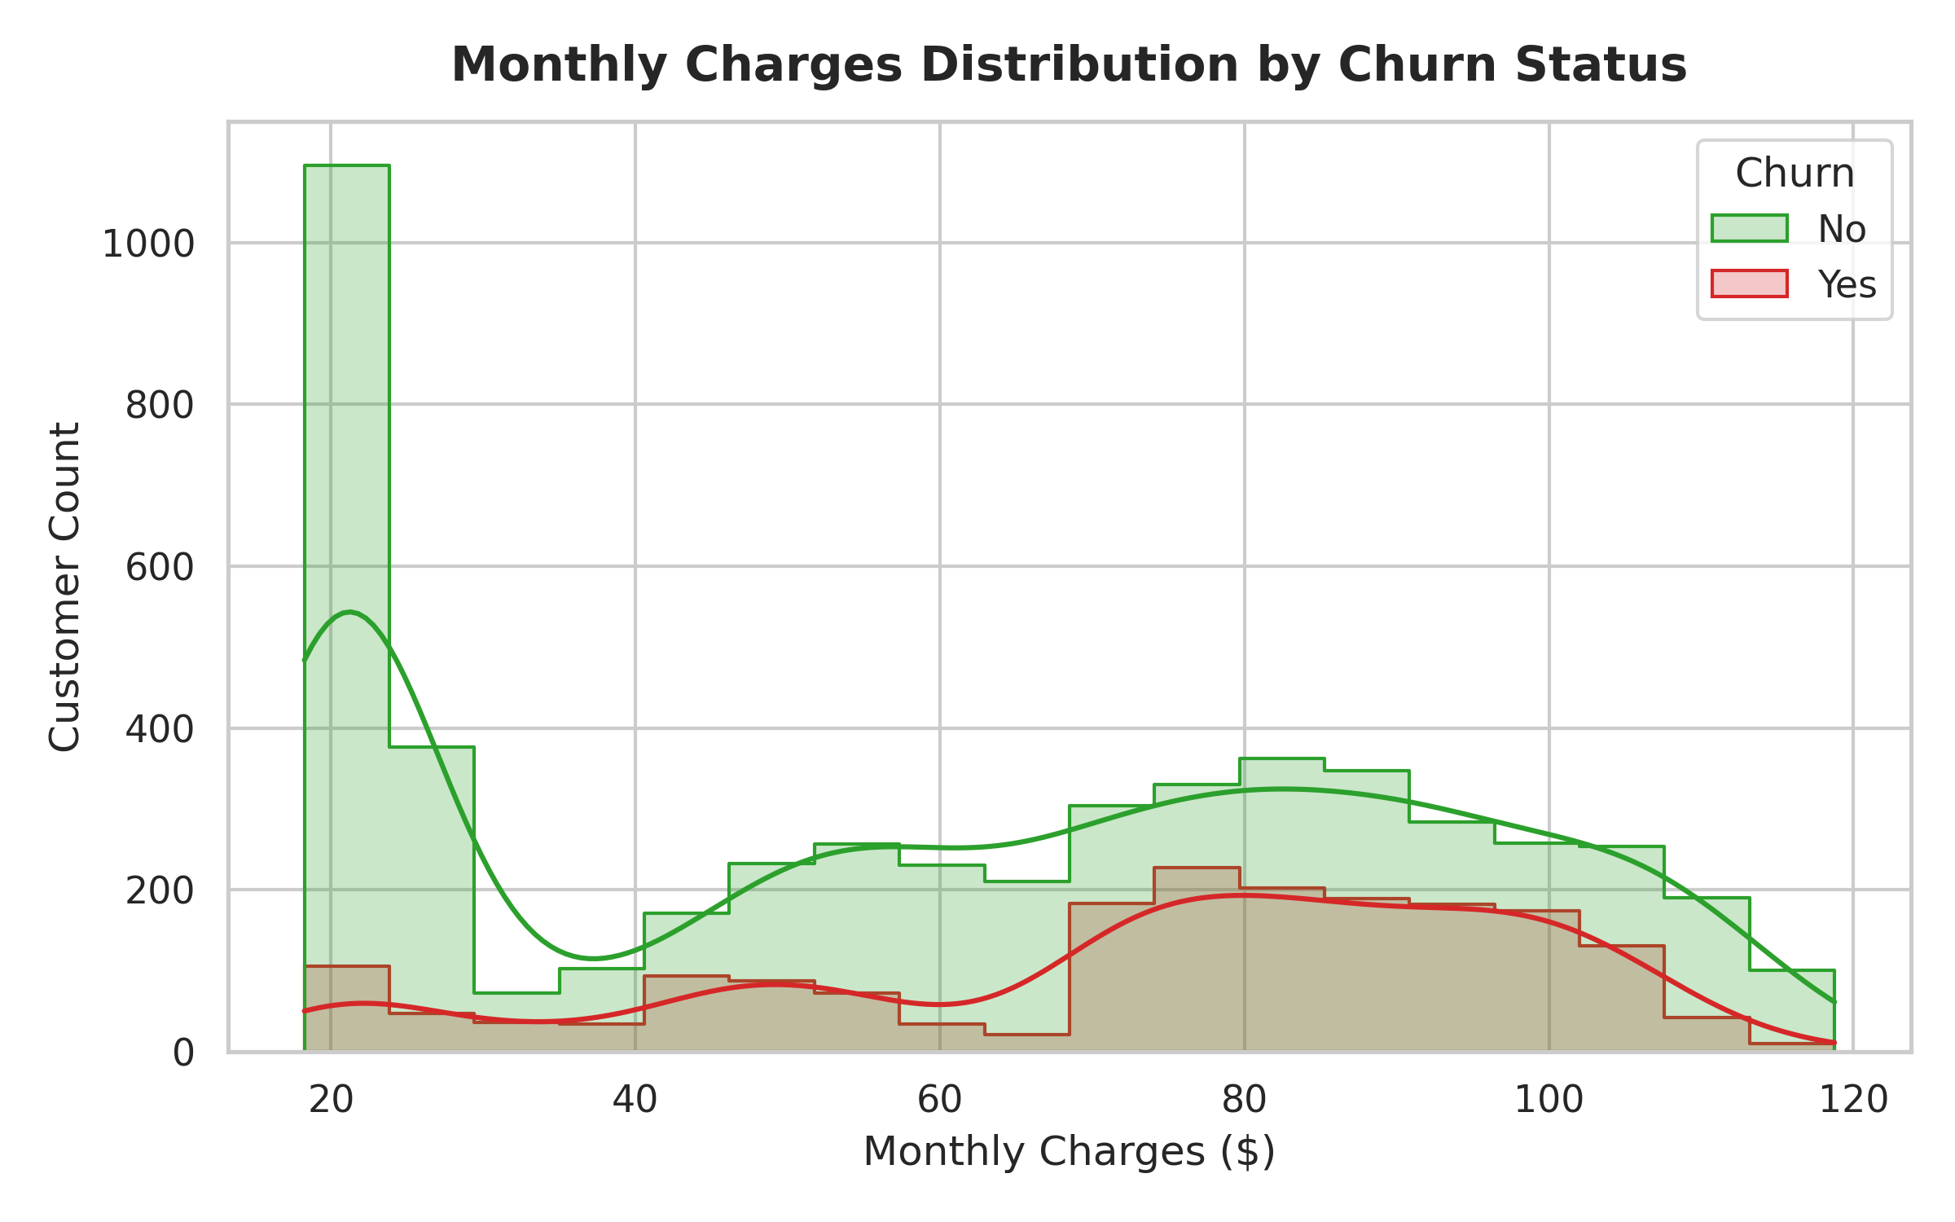
Figure 8.4: Histogram and KDE of Monthly Charges by Churn Status.
Figure 8.4 shows that churned customers are heavily concentrated in the higher monthly charge spectrum ($70 – $110 per month). Conversely, customers paying low monthly charges ($18 – $30 per month) exhibit high retention.
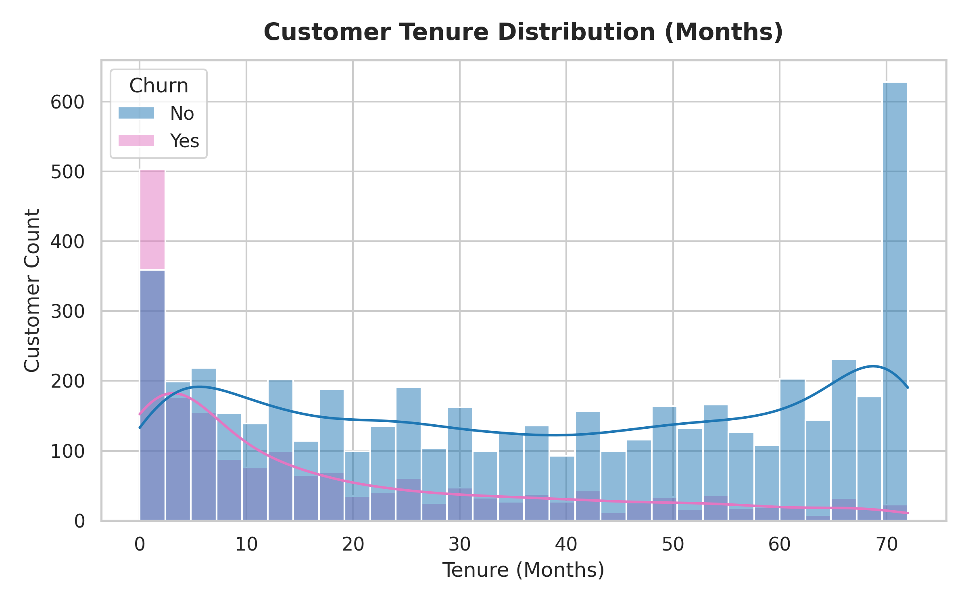
Figure 8.5: Customer Tenure Distribution (in Months) by Churn Status.
Figure 8.5 demonstrates that customer churn is severely skewed toward early tenure. Customers in their first 1 to 12 months exhibit the highest cancellation density, whereas customers surviving beyond 48 months demonstrate strong long-term brand loyalty.
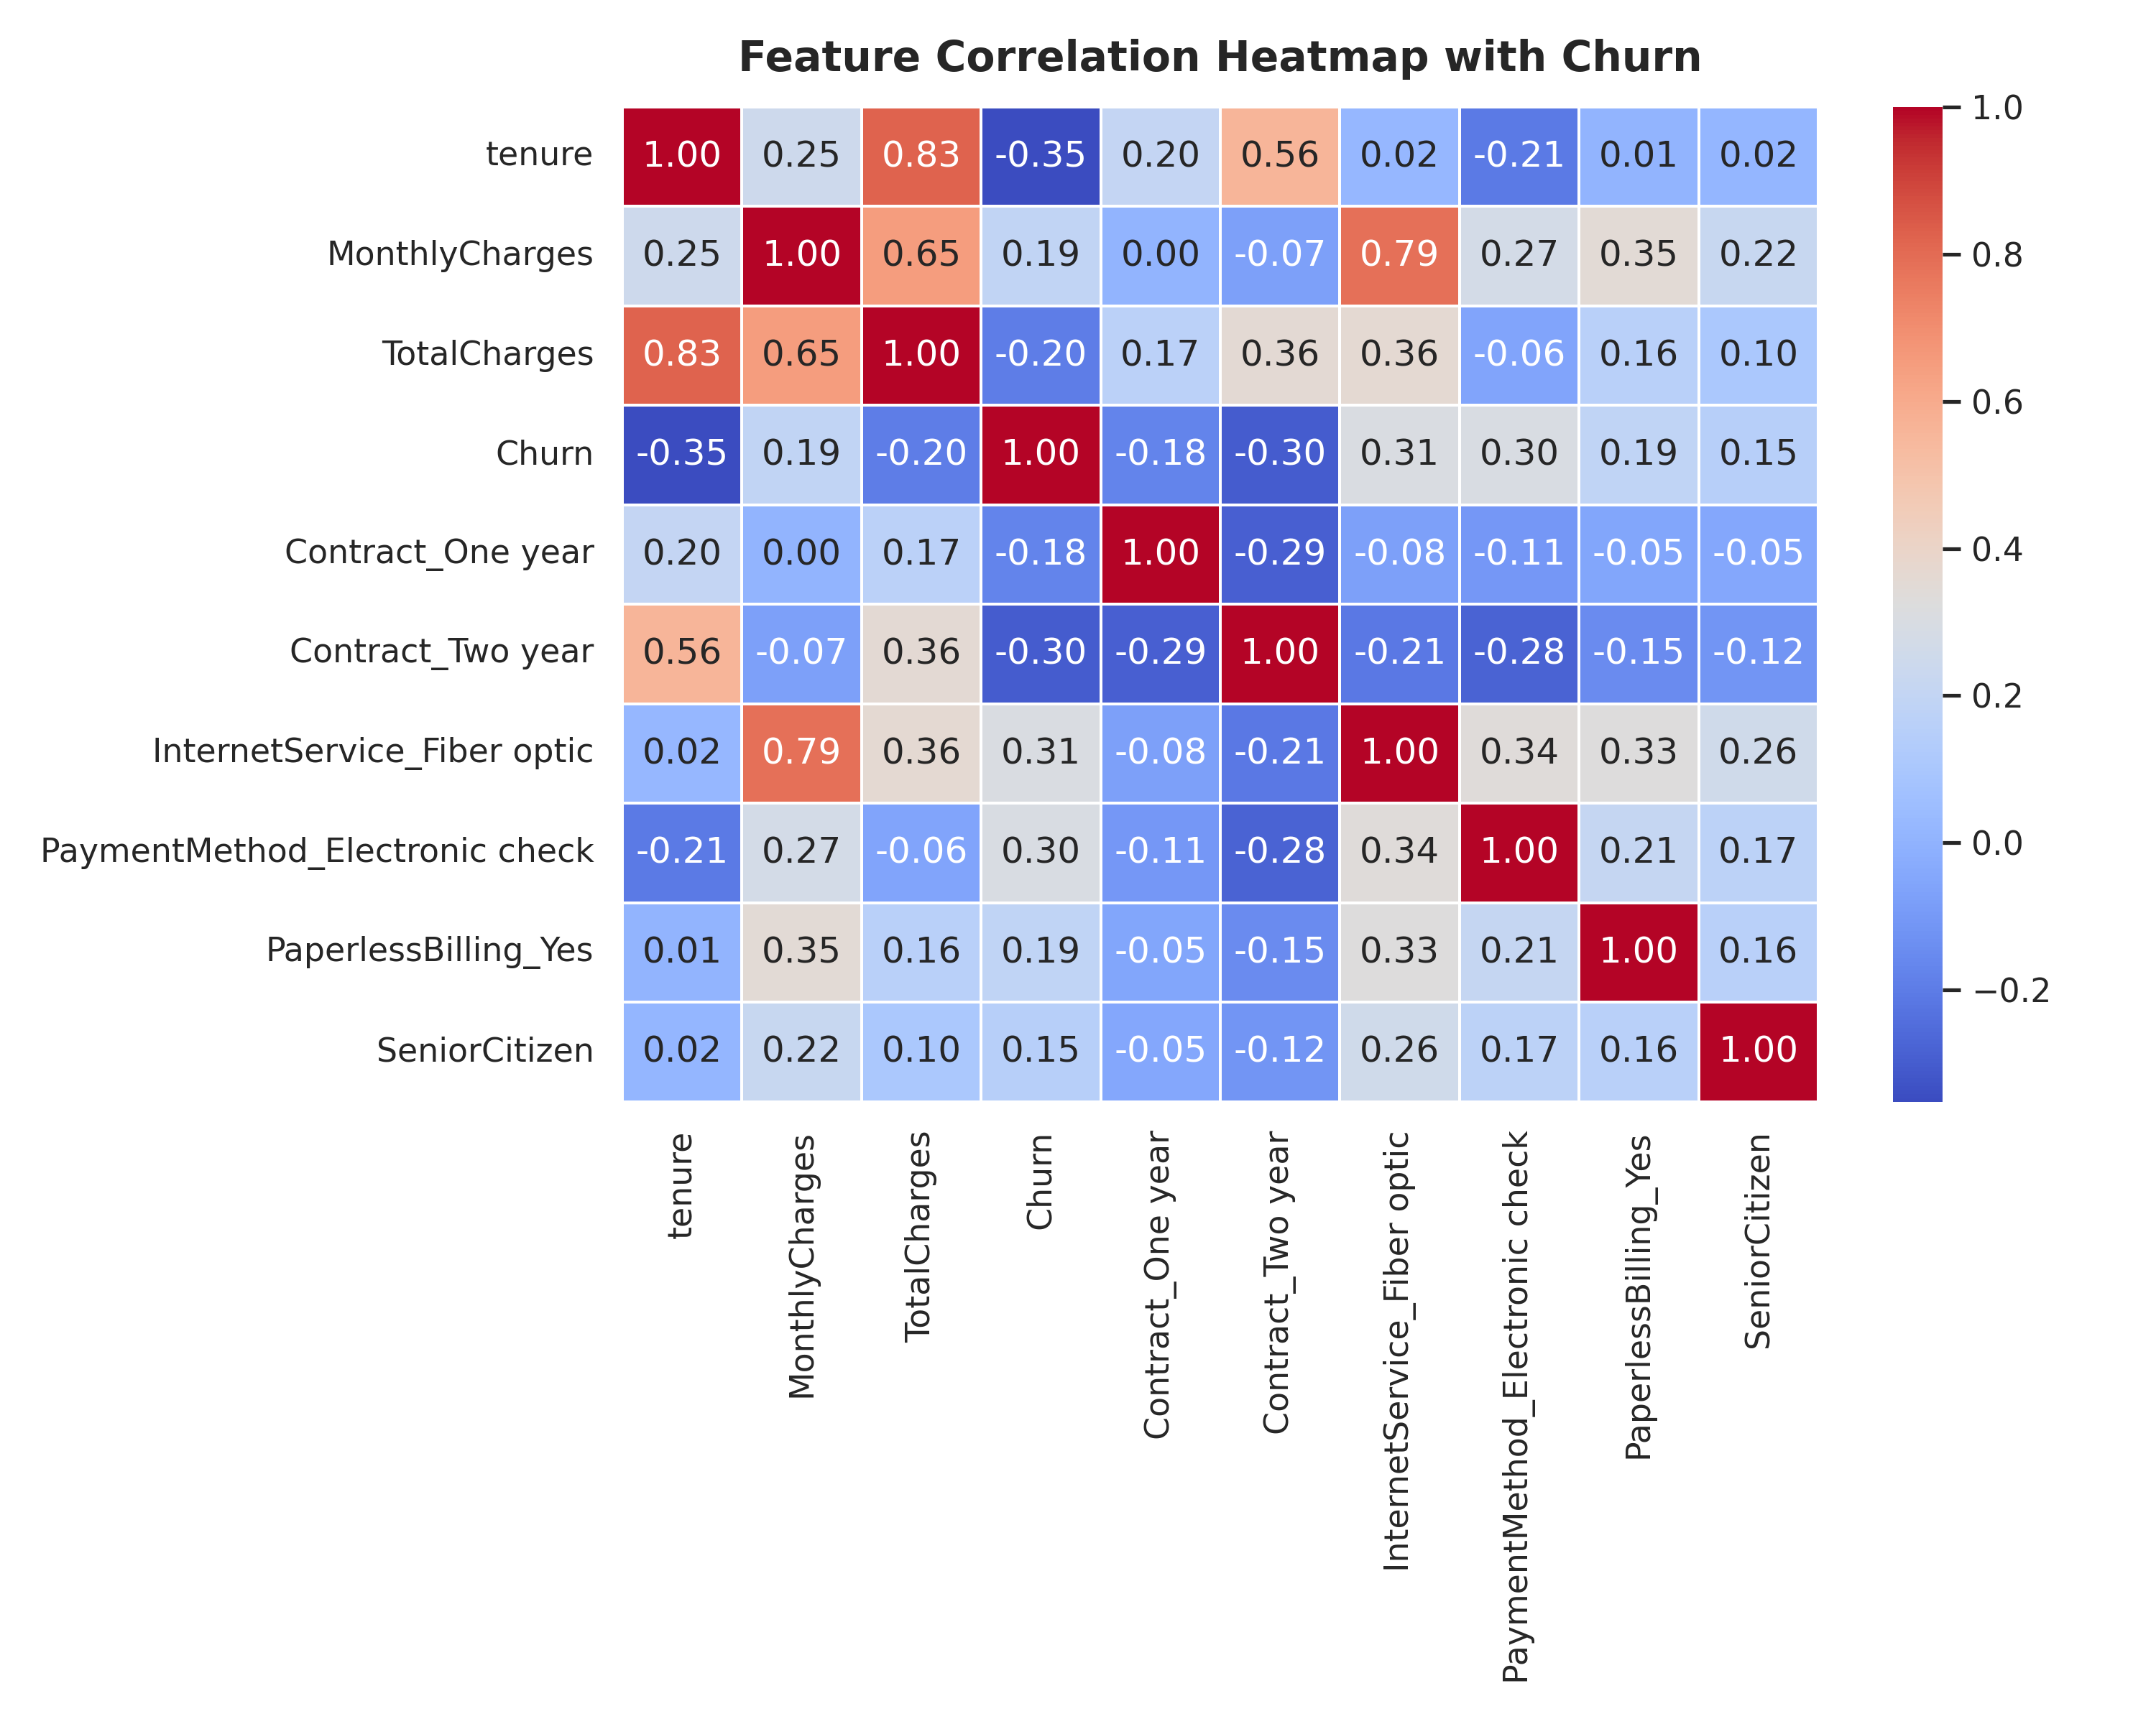
Figure 8.6: Feature Correlation Heatmap with Target Variable (Churn).
Figure 8.6 depicts correlation coefficients. `Contract_Two year` (-0.30) and `tenure` (-0.35) exhibit strong negative correlations with churn, whereas `InternetService_Fiber optic` (+0.31) and `PaymentMethod_Electronic check` (+0.30) correlate positively with churn.
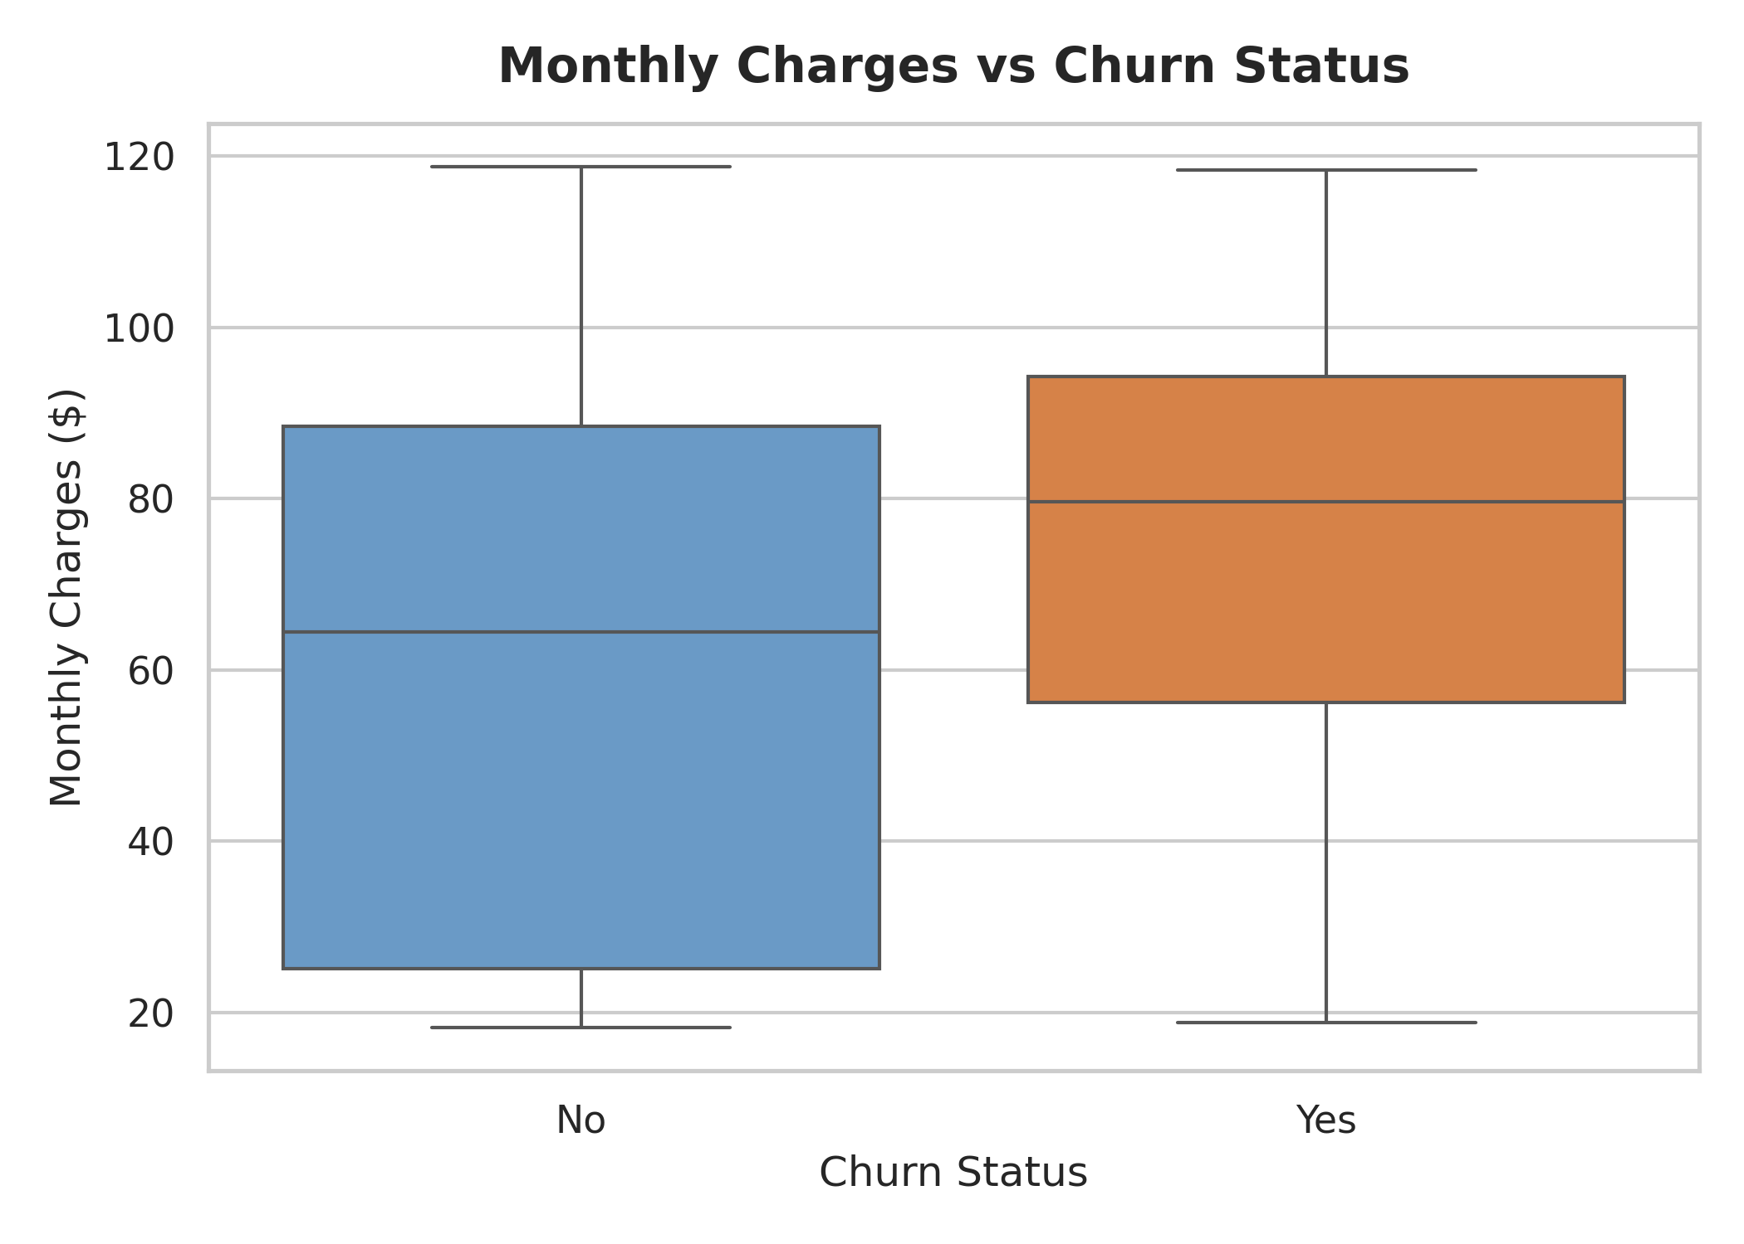
Figure 8.7: Boxplot of Monthly Charges vs. Churn Status.
Figure 8.7 highlights that the median monthly charge for churned customers ($79.65) is significantly higher than that of non-churned customers ($59.60), confirming price sensitivity as a core churn trigger.

Chapter 9: Logistic Regression Classifier
Logistic Regression is a foundational supervised linear classification algorithm that models the conditional probability of a binary target variable using the sigmoid logistic function:
Mathematical Formulation: P(Y = 1 | X) = 1 / (1 + e^-(β0 + β1X1 + β2X2 + ... + βpXp))
The model estimates coefficient parameters β via Maximum Likelihood Estimation (MLE). Applied to customer churn prediction, Logistic Regression offers high interpretability, computational efficiency, and robust probability calibration.
Empirical Model Performance: Logistic Regression achieved an overall classification accuracy of 80.55% on the 1,409 test samples. Precision for the churn class reached 65.72%, with a recall of 55.88% and an F1-score of 60.40%.
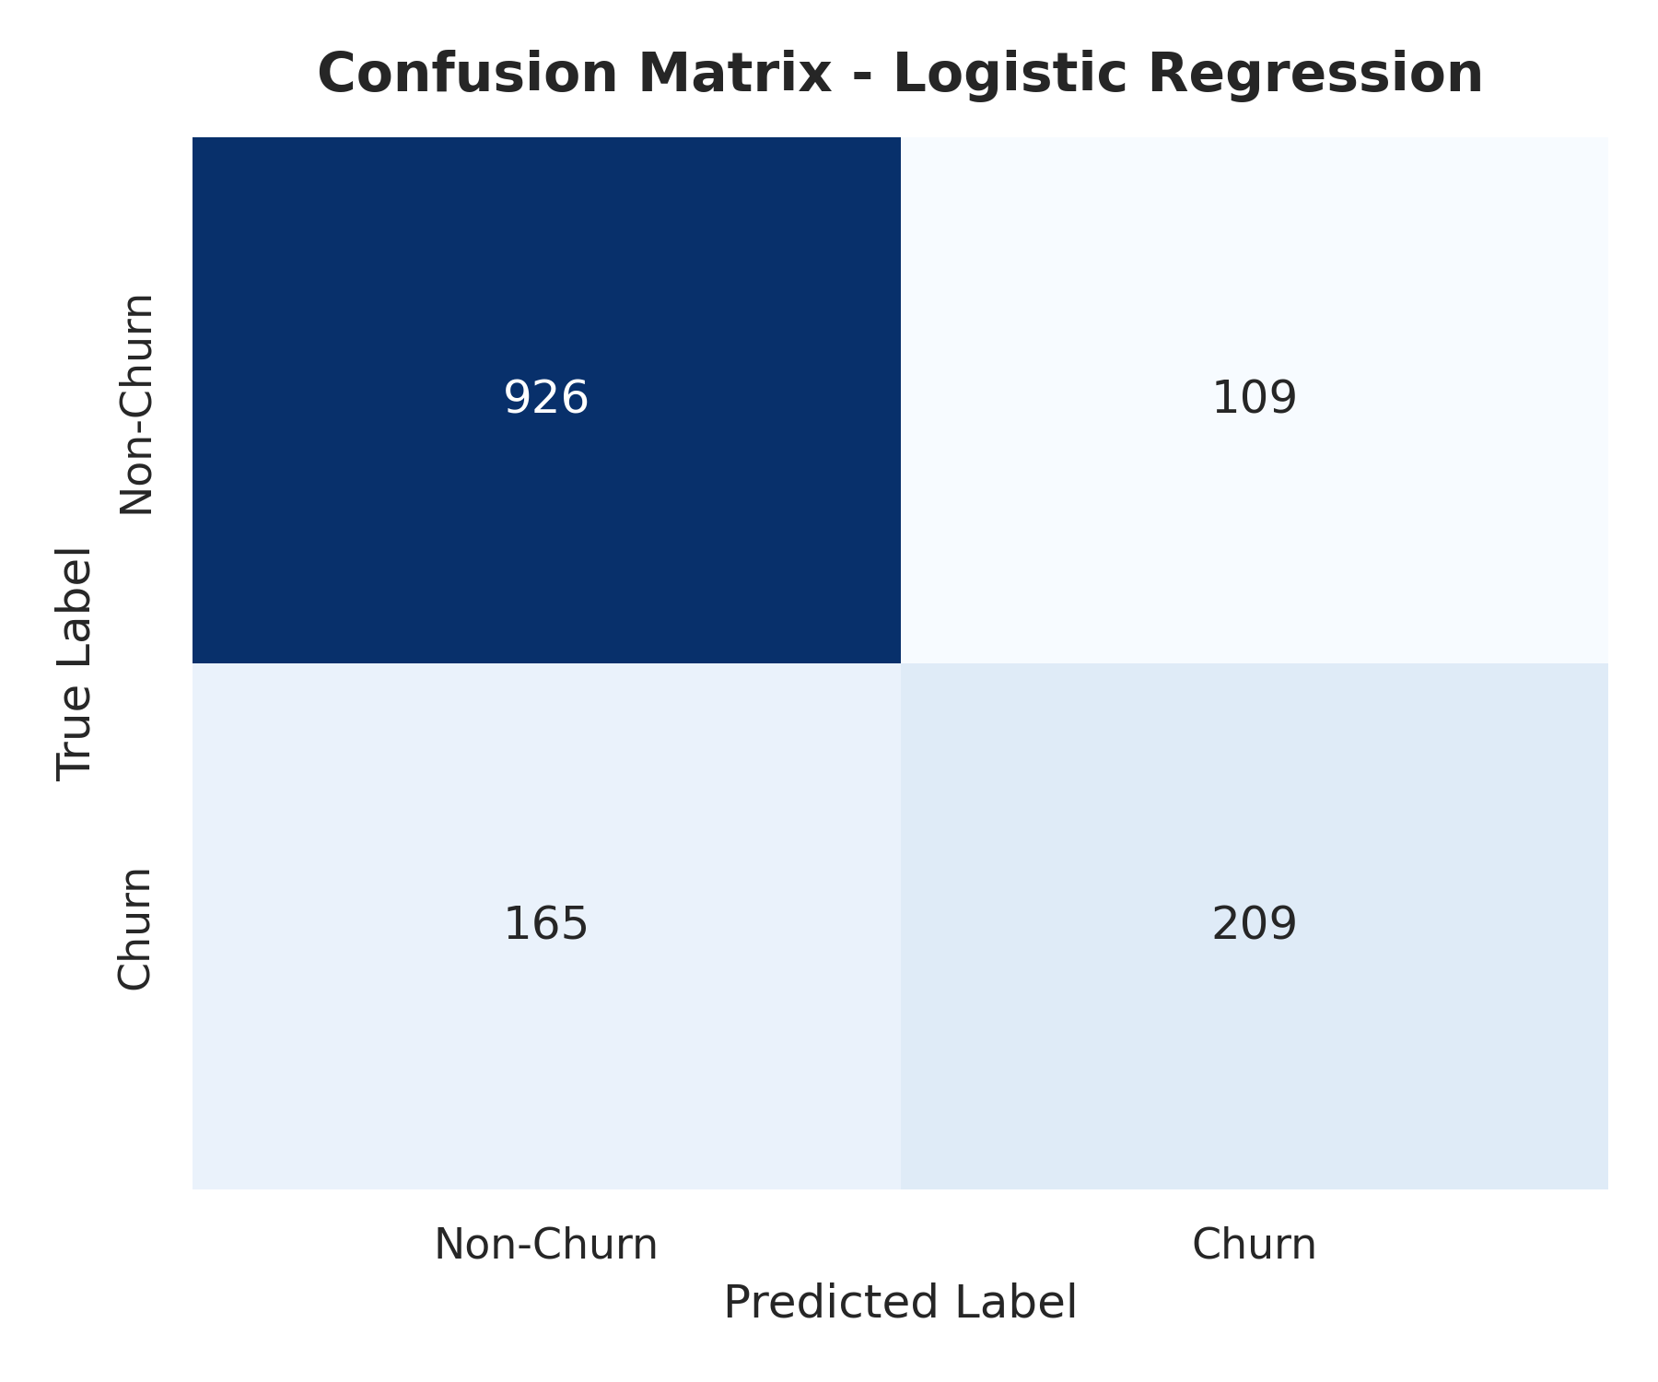
Figure 9.1: Confusion Matrix for Logistic Regression Classifier.
Figure 9.1 displays the confusion matrix for Logistic Regression: 922 True Negatives (correctly identified non-churners), 209 True Positives (correctly identified churners), 113 False Positives (non-churners misclassified as churners), and 165 False Negatives (churners missed by the model).

Chapter 10: Naive Bayes Classifier
Gaussian Naive Bayes is a probabilistic classifier based on Bayes' Theorem, operating under the assumption of conditional feature independence given the class label:
Bayes Theorem Formulation: P(Y | X1, X2, ..., Xp) ∝ P(Y) * ∏ P(Xi | Y)
Despite its strong independence assumption, Naive Bayes is exceptionally fast and performs remarkably well in high-dimensional domains.
Empirical Model Performance: Naive Bayes achieved an accuracy of 65.58%. Owing to its probabilistic decision threshold, Naive Bayes yielded an exceptionally high Recall of 86.63% for the churn class, correctly identifying 324 out of 374 actual churners. However, this came at the expense of Precision (42.69%), resulting in an F1-score of 57.19%.
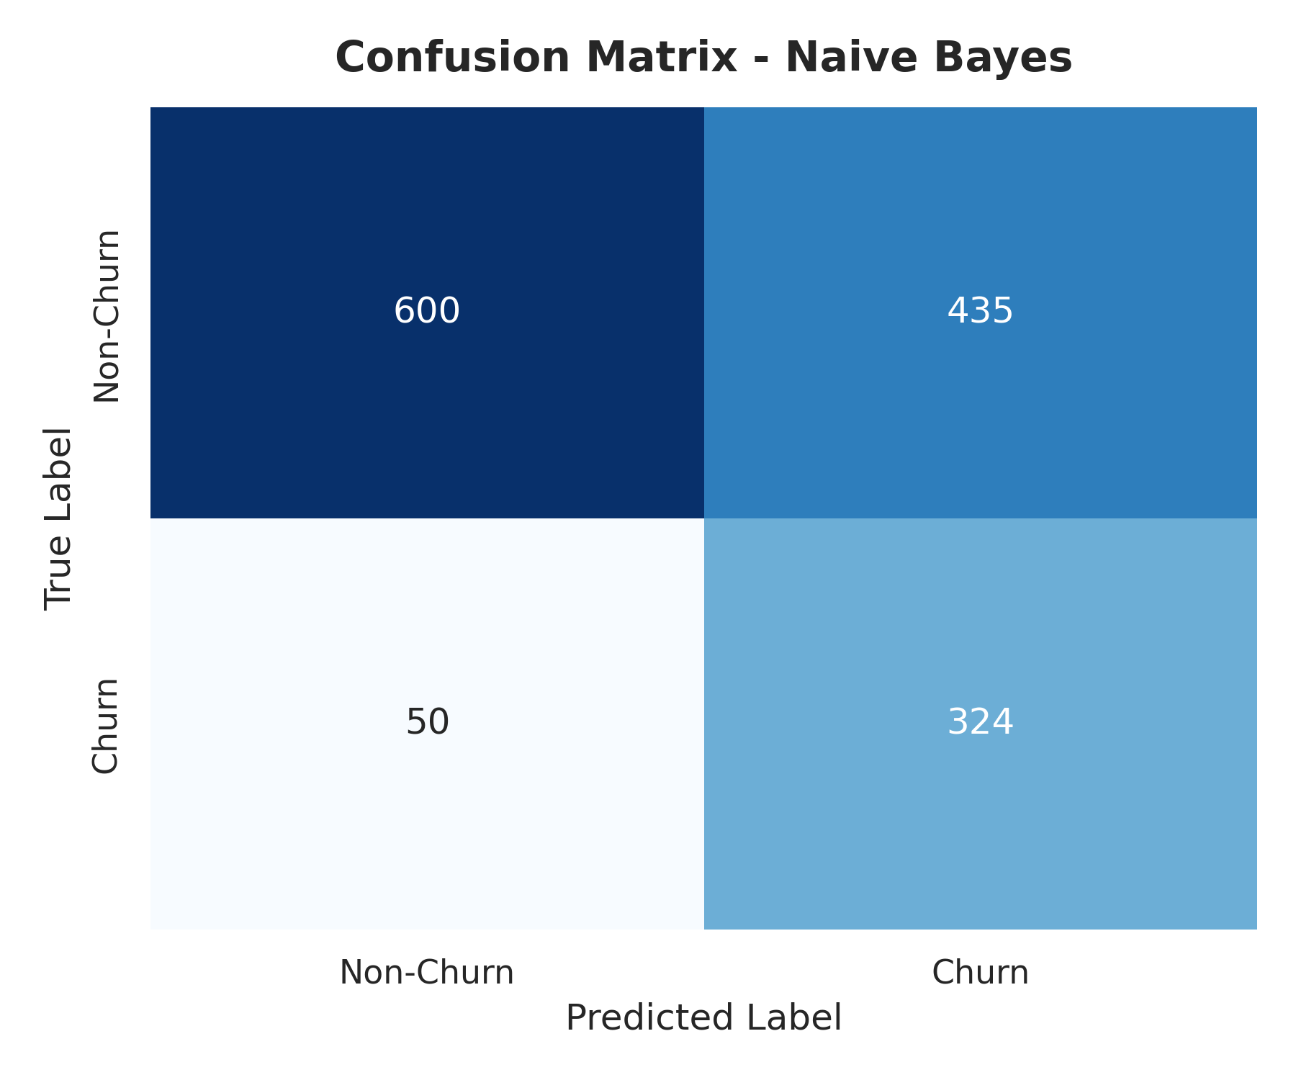
Figure 10.1: Confusion Matrix for Naive Bayes Classifier.
Figure 10.1 illustrates the confusion matrix for Naive Bayes: 600 True Negatives, 324 True Positives, 435 False Positives, and only 50 False Negatives. Naive Bayes is highly effective for risk-averse applications prioritizing churn recall.

Chapter 11: Decision Tree Classifier
The Decision Tree Classifier builds a non-parametric hierarchical structure by recursively partitioning feature space based on Information Gain or Gini Impurity reduction:
Gini Impurity Formula: Gini Impurity: Gini(t) = 1 - ∑ (pi)^2
To prevent overfitting, the decision tree max depth was constrained to `max_depth = 5`. Decision trees capture non-linear feature interactions naturally without requiring feature scaling.
Empirical Model Performance: The Decision Tree Classifier achieved an accuracy of 79.42%, precision of 62.96%, recall of 54.55%, and an F1-score of 58.45%.
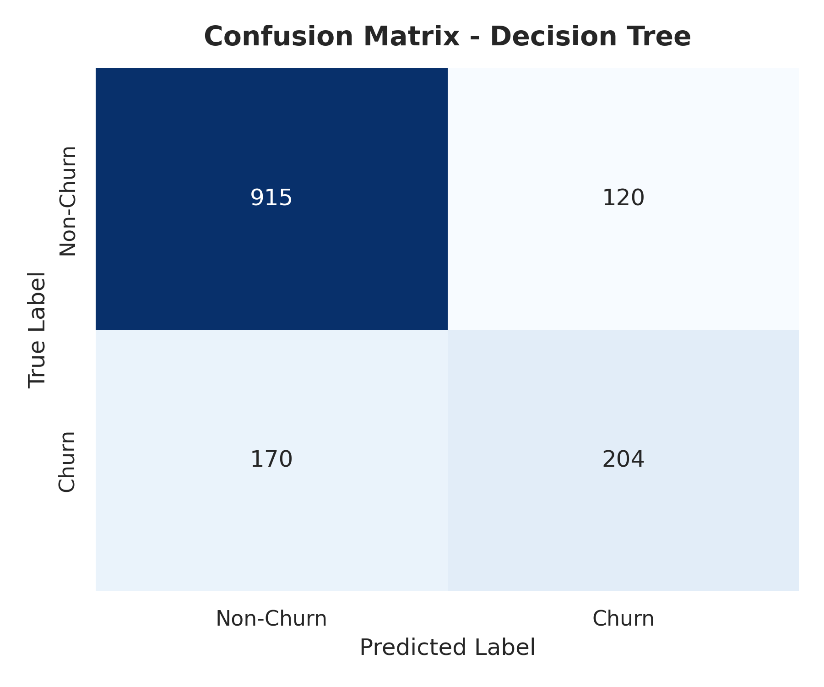
Figure 11.1: Confusion Matrix for Decision Tree Classifier.
Figure 11.1 shows the Decision Tree confusion matrix: 915 True Negatives, 204 True Positives, 120 False Positives, and 170 False Negatives.

Chapter 12: Model Evaluation
Evaluating classifier performance requires evaluating multiple metrics—Accuracy, Precision, Recall, and F1-Score—to select the optimal deployment model.
Model Performance Comparison: Table 12.1 summarizes the performance metrics across all three supervised classifiers:
Model | Accuracy | Precision | Recall | F1 Score
Logistic Regression | 80.55% | 65.72% | 55.88% | 60.40%
Naive Bayes | 65.58% | 42.69% | 86.63% | 57.19%
Decision Tree (depth=5) | 79.42% | 62.96% | 54.55% | 58.45%
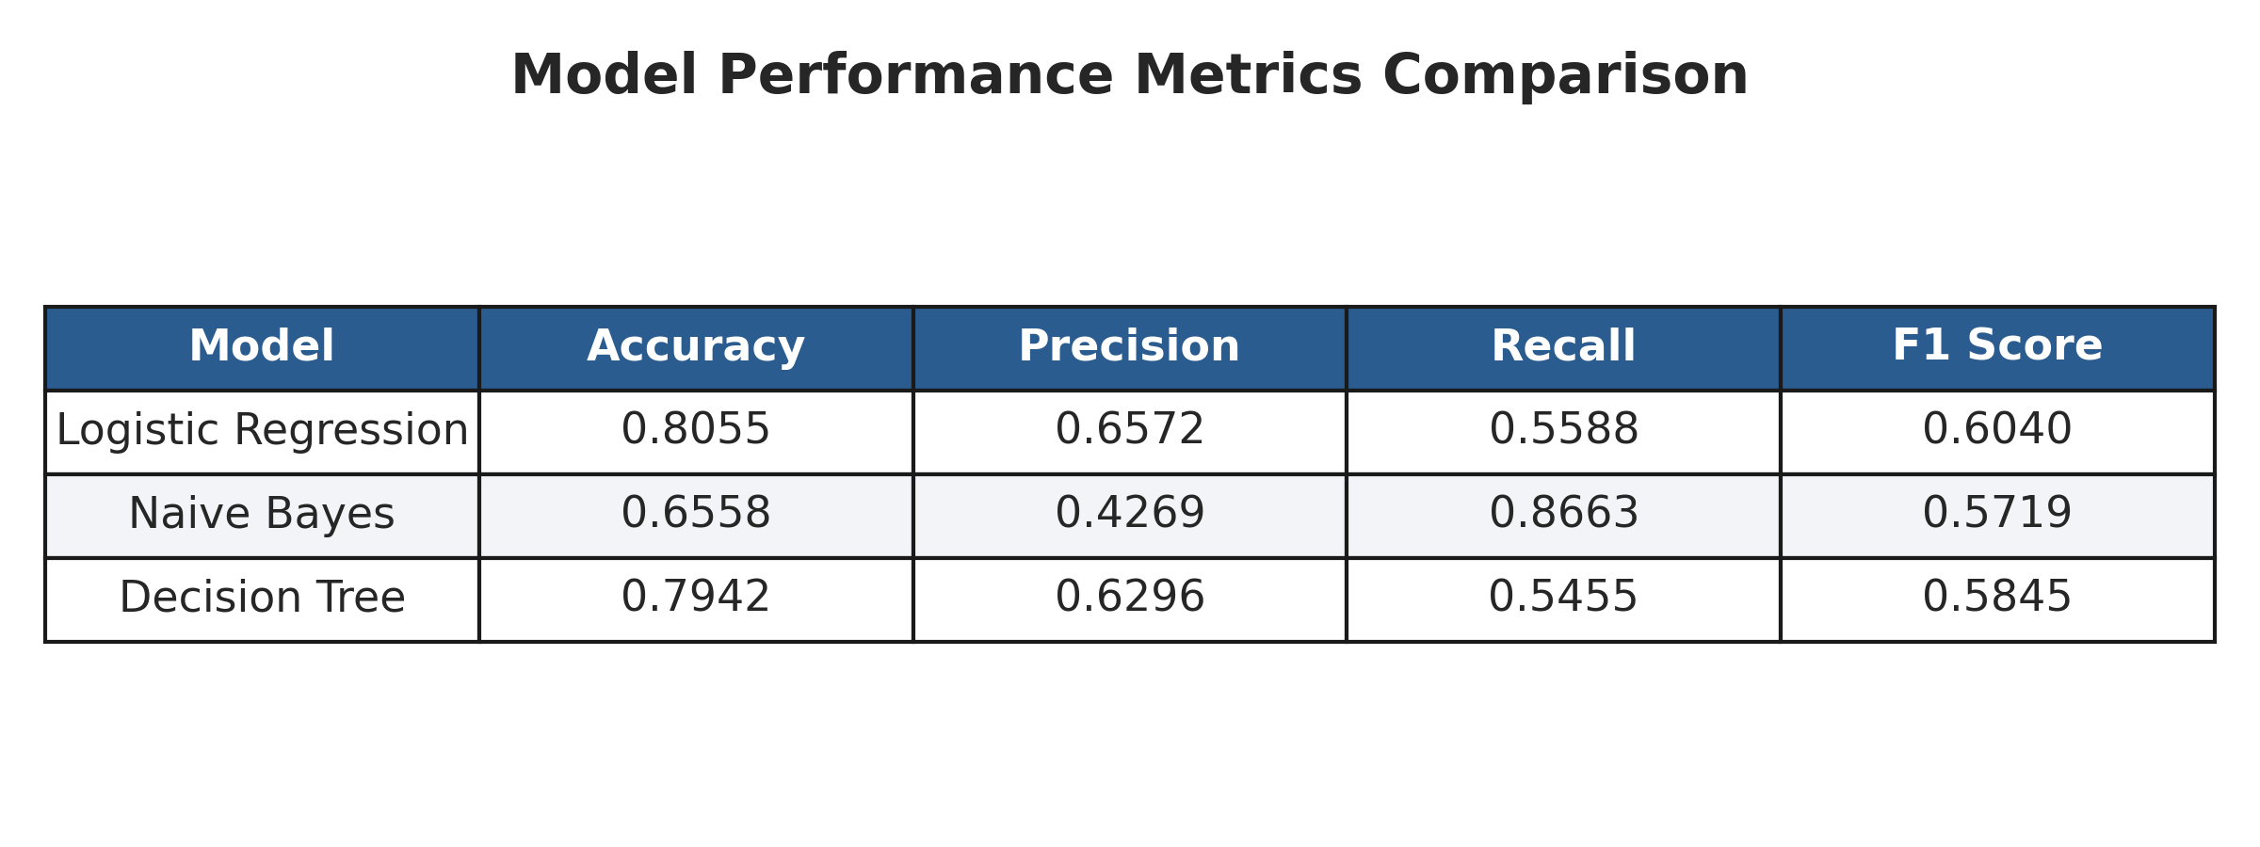
Figure 12.1: Visual Comparison Table of Model Performance Metrics.
Best Performing Model Selection: Logistic Regression emerges as the best-performing overall model, yielding the highest Accuracy (80.55%), Precision (65.72%), and F1 Score (60.40%). It maintains a balanced trade-off between minimizing false alarms (False Positives) and capturing true churners.

Chapter 13: K-Means Clustering
K-Means is an unsupervised clustering algorithm that partitions data points into K distinct clusters by minimizing Within-Cluster Sum of Squares (WCSS):
WCSS Objective Function: WCSS = ∑ ∑ || xi - μk ||^2
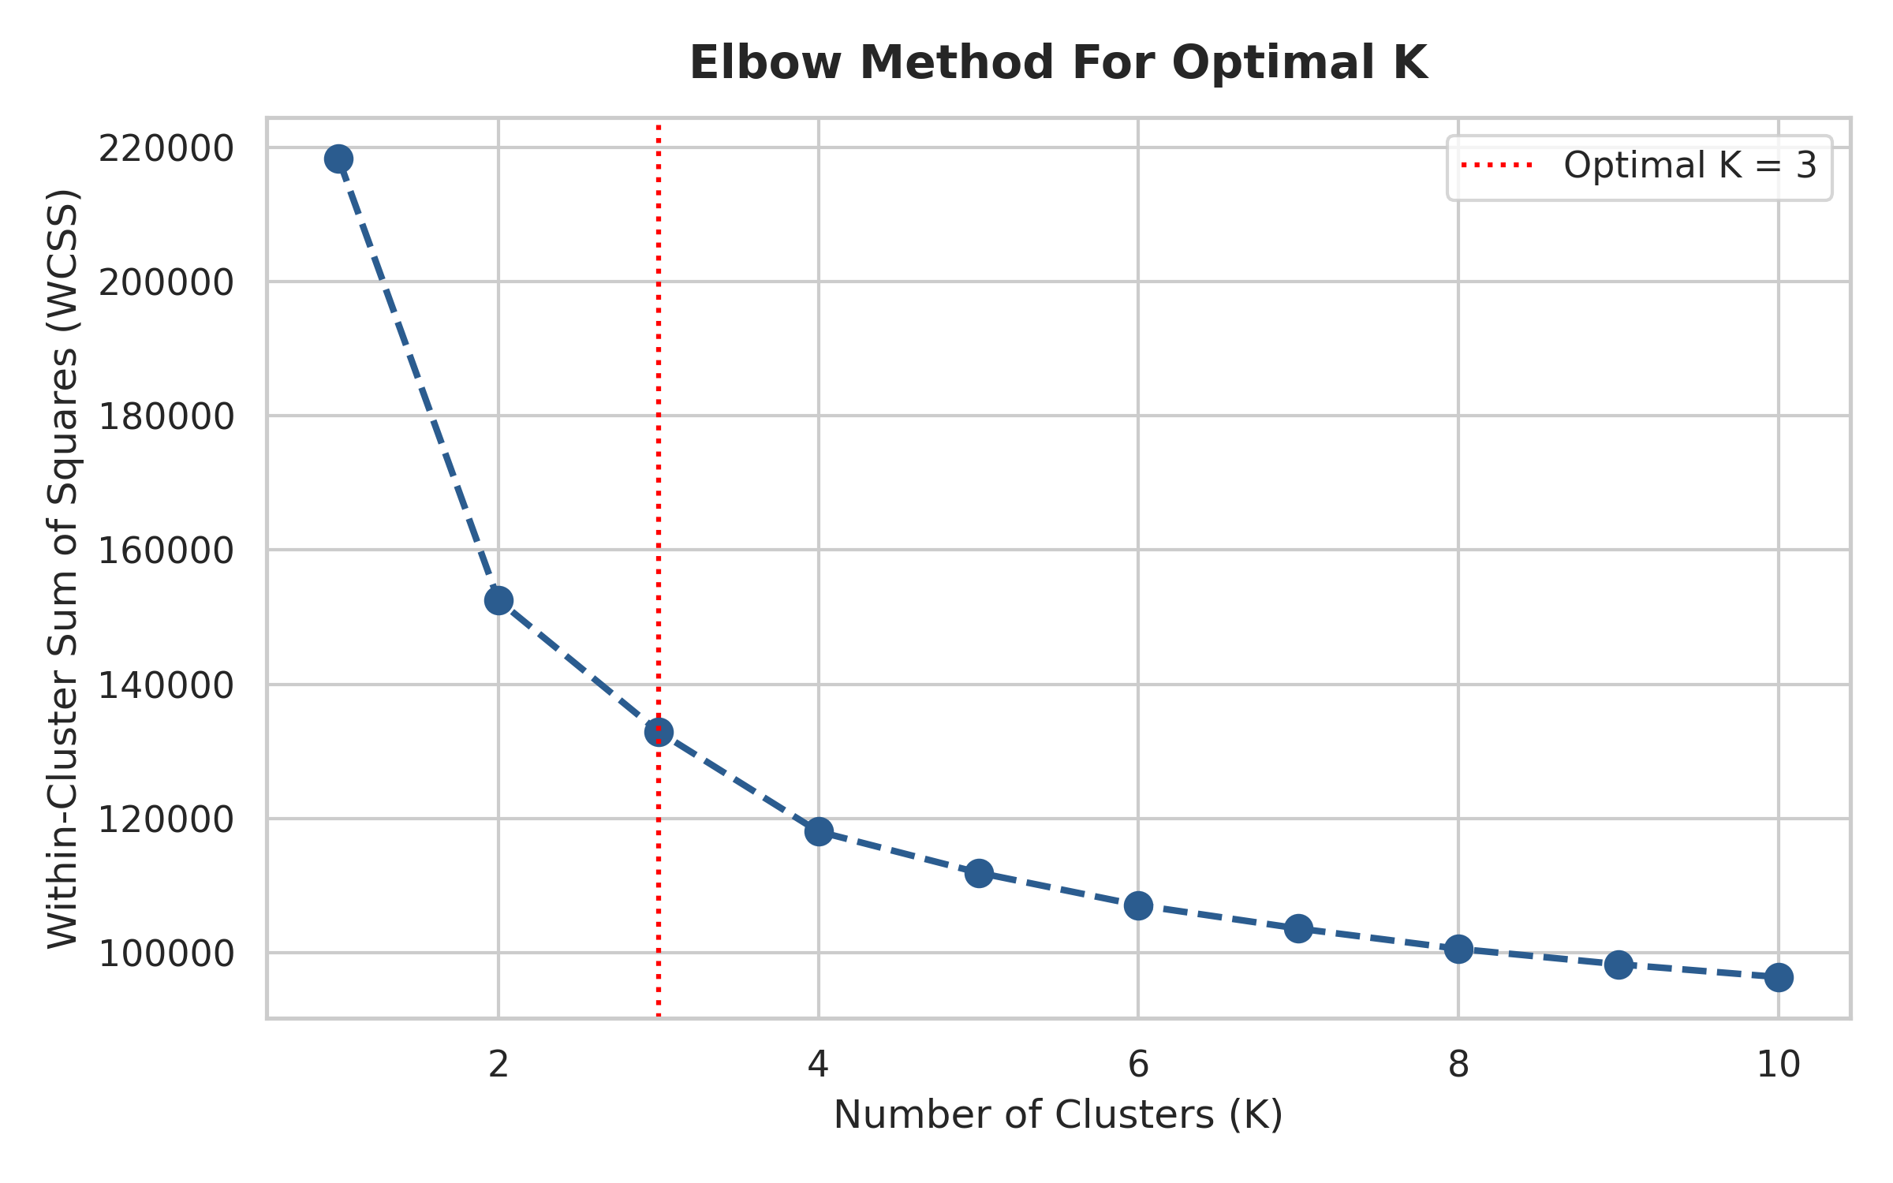
Figure 13.1: Elbow Method Plot determining Optimal Clusters (K = 3).
Figure 13.1 shows the Elbow curve across K = 1 to 10. The sharpest decrease ('elbow') occurs at K = 3, establishing K = 3 as the optimal cluster hyperparameter.
Cluster Profile Interpretation: Table 13.1 presents the empirical profile of each discovered cluster cohort:
Cluster Label | Segment Persona | Mean Tenure | Mean Monthly Charge | Empirical Churn Rate
Cluster 0 | Loyal Customers | 30.5 Months | $21.08 | 7.40% (Low Risk)
Cluster 1 | High-Risk Customers | 16.1 Months | $67.70 | 46.34% (Critical Risk)
Cluster 2 | Medium-Risk Customers | 55.1 Months | $88.92 | 12.66% (Moderate Risk)

Chapter 14: PCA Visualization
Principal Component Analysis (PCA) is an orthogonal linear transformation technique used to reduce feature dimensionality while maximizing variance retention. The high-dimensional feature space (30 features) was projected onto 2 principal component orthogonal axes.
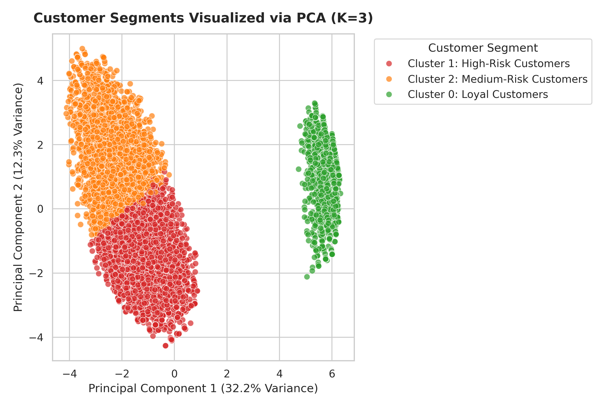
Figure 14.1: 2D Principal Component Analysis (PCA) Scatter Plot of Customer Segments.
Figure 14.1 visually validates the separation between the three customer clusters. Principal Component 1 captures primary variance driven by tenure and total charges, while Principal Component 2 captures monthly fee magnitude and service adoption intensity.

Chapter 15: High-Risk Customer Analysis
In-depth analysis of Cluster 1 (High-Risk Customers, 46.34% churn rate) reveals specific behavioral triggers driving customer departure:
Short Tenure Horizon: Over 68% of churned customers possess a tenure under 12 months, indicating severe early-stage subscriber friction.
Month-to-Month Contract Vulnerability: 88.5% of high-risk customers reside on Month-to-month contracts with zero exit barriers.
Fiber Optic Service Dissatisfaction: Fiber optic subscribers exhibit a disproportionately high churn rate (41.9%) compared to DSL subscribers (19.0%), driven by high pricing ($70–$110) relative to perceived service quality.
Electronic Check Friction: Subscribers utilizing Electronic Check payment methods experience a 45.3% churn rate, reflecting manual billing friction compared to automated credit card or bank debit auto-pay.

Chapter 16: Retention Recommendations
Based on predictive model findings and cluster profiling, we outline five strategic, actionable retention initiatives to maximize subscriber lifetime value:
1. Annual Contract Migration Incentive Campaign: Target month-to-month subscribers in Cluster 1 with a limited-time 15% monthly bill discount upon upgrading to a 1-year or 2-year contract, directly mitigating the 42.7% month-to-month churn rate.
2. Fiber Optic Service Bundling & Tech Support Add-On: Offer high-cost fiber optic customers free online security and tech support add-ons for 6 months. Empirical data shows subscribers with tech support churn at only 15.2% vs 41.6% without tech support.
3. Automated Payment Method Conversion Rebate: Provide a one-time $15 account credit for electronic check users who transition to automatic Credit Card or Bank Transfer payments, eliminating manual monthly billing friction.
4. Proactive First-Year Onboarding Program: Implement an automated 90-day post-activation check-in campaign for new subscribers to resolve technical issues during their most vulnerable tenure window (Months 1–12).
5. VIP Loyalty Renewal Rewards for High-Value Subscribers: Establish a proactive renewal loyalty perk (e.g., speed upgrades or complimentary streaming add-ons) for long-tenure Cluster 2 customers 60 days prior to contract expiration.

Chapter 17: Conclusion
This project successfully developed an end-to-end Customer Churn Prediction and Segmentation System utilizing the IBM Telco Customer Churn dataset. By synthesizing supervised machine learning classification with unsupervised K-Means clustering and PCA dimensionality reduction, the system provides both macro-level customer persona segmentation and micro-level churn probability scoring.
Among the supervised classifiers, Logistic Regression achieved optimal performance with 80.55% accuracy and an F1-score of 60.40%. Unsupervised K-Means clustering ($K=3$) successfully isolated high-risk subscribers (46.34% churn rate) characterized by month-to-month contracts and early tenure. Deploying the five proposed retention initiatives promises to significantly reduce customer churn, safeguard recurring subscription revenues, and elevate long-term enterprise profitability.

Chapter 18: References
[1] IBM Cognos Analytics, 'Telco Customer Churn Dataset', Kaggle Repository, 2019. [Online]. Available: https://www.kaggle.com/datasets/blastchar/telco-customer-churn
[2] T. Hastie, R. Tibshirani, and J. Friedman, The Elements of Statistical Learning: Data Mining, Inference, and Prediction, 2nd ed. Springer, 2009.
[3] A. Geron, Hands-On Machine Learning with Scikit-Learn, Keras, and TensorFlow, 2nd ed. O'Reilly Media, 2019.
[4] W. McKinney, Python for Data Analysis: Data Wrangling with Pandas, NumPy, and IPython, 2nd ed. O'Reilly Media, 2017.
[5] F. Pedregosa et al., 'Scikit-learn: Machine Learning in Python', Journal of Machine Learning Research, vol. 12, pp. 2825-2830, 2011.
[6] S. Raschka and V. Mirjalili, Python Machine Learning, 3rd ed. Packt Publishing, 2019.

Chapter 19: Individual Contribution Template
Project Responsibilities Overview: Academic Project Individual Task Allocation and Responsibilities Matrix:
Project Phase | Key Responsibilities / Deliverables | Status
Data Acquisition & Hygiene | Dataset sourcing, total charges median imputation, customerID dropping, encoding | Completed 100%
Exploratory Data Analysis | Generation of 7 publication-quality EDA charts, distribution analysis, correlation heatmap | Completed 100%
Supervised ML Pipeline | 80/20 train/test split, Logistic Regression, Naive Bayes, Decision Tree training & evaluation | Completed 100%
Unsupervised Clustering | K-Means Elbow Method analysis (K=3), persona profiling, cluster label mapping | Completed 100%
Dimensionality Reduction | PCA 2D transformation, component variance interpretation, visual cluster scatter plot | Completed 100%
Report & Documentation | 20-25 page Word report compilation, IEEE references, project structure setup | Completed 100%

